- Select section of tasks from the ‘Task Summary Chart’ for the project via the desktop
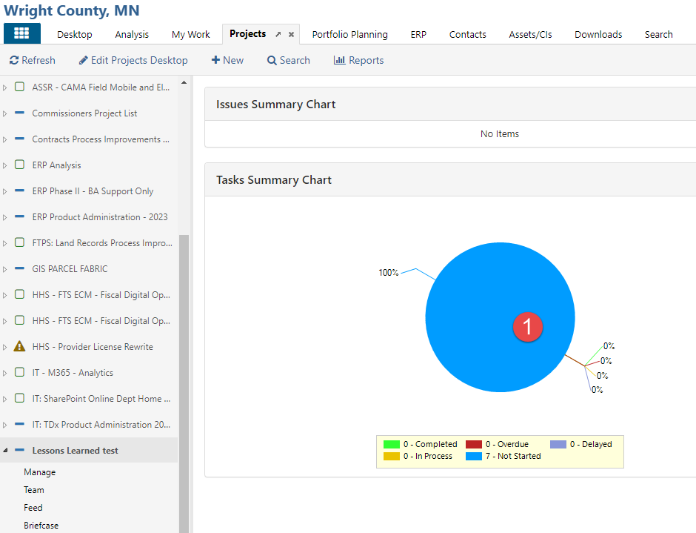

- Select a specific task (card)
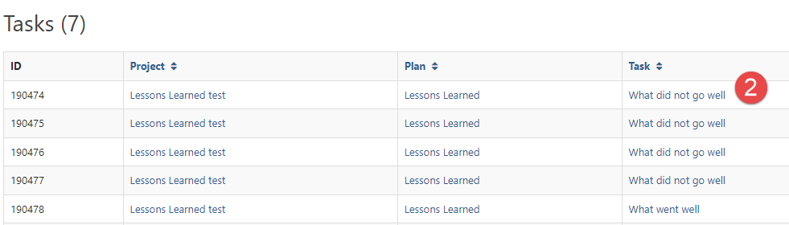
- Select ‘Edit’ for the task
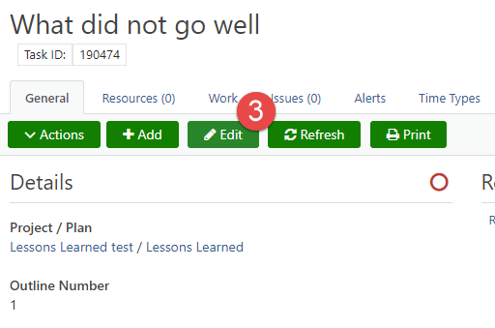
- Scroll down and see the 10 fields, enter data
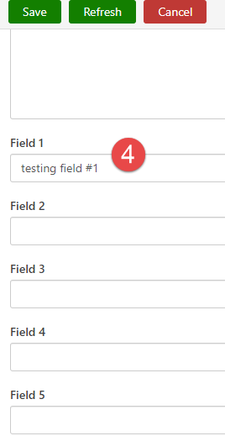

- This data shows up in reporting on tasks via analysis
