When I make an allocation change on this screen:
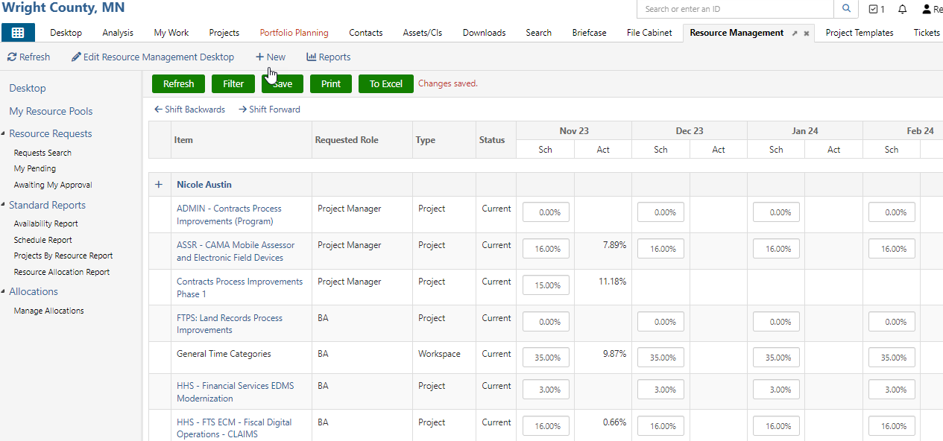
I DON’T want to trigger a resource request and/or ANY notification to the PMs
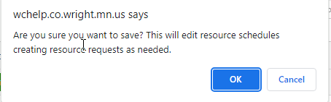

Like this one:
